1. 1. Actor – refers to the role/activity that a person or another piece of technology that interacts with the system either through its usage or integration
   2. Use Case – refers to a set of activities/instructions to produce a certain outcome with the system that provides benefits to the actors
   3. System Boundary – refers to the limits of the system and what the system can perform, usually involving anywhere from 3 to 9 use cases
   4. Relationship – refers to the connection between actors and use cases to see how they interact and are involved with each other
2. 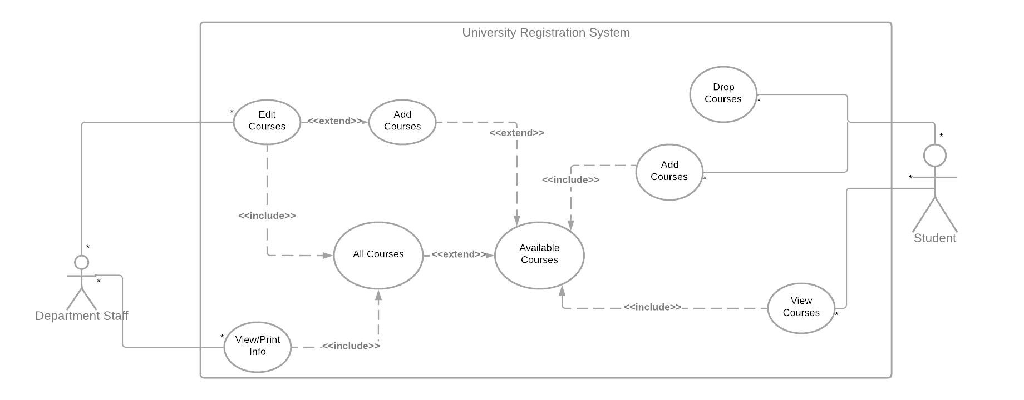Diagram

   Description automatically generatedDiagram

   Description automatically generatedGraphical user interface, text, application, email

   Description automatically generatedGraphical user interface, text, application, email

   Description automatically generated
3. A Builder Creational Pattern works by having a *reader* to invoke the *builder* to create an object. The code example I used has the “customer”, as a *reader*, and it invokes the “waiter”, as the *converter*, to invoke the “pizza making staff”, as the *builder*. I’ve added more code to verify that the pizza made had the correct ingredients as well to show that the “waiter” was properly conversing with the “pizza making staff” as it retrieves the pizza. Text

   Description automatically generatedA screenshot of a computer

   Description automatically generatedText

   Description automatically generated

A Singleton Creational Design Pattern involves having the class being called upon make an instance of itself for global use as well as performing this on the first initialization. The example they used to describe its use is how the election of the United States President is selected. When the US Government is ready for selecting a new president, they hold an election. In a Singleton use of this scenario, the Government class would call upon itself to hold an election method to select the president. The selection after the method is called is stored in that single instance as a public variable that can be publicly accessed globally. Text
